DATA STRUCTURE LAB
LAB TASK 01



By
MISBAH KHALID
FA25-BCS-005

Submitted to,
Mr. BILAL BUKHARI
September 10, 2026

Department of Computer Sciences
COMSATS University Islamabad,
Attock Campus

LAB TASK 01

CODE:
#include<iostream>
using namespace std;
int main(){
int start, stop,x,sum=0;
cout<<"Enter X:";
cin>>x;
cout<<"Enter start :";
cin>>start;
cout<<"Enter stop:";
cin>>stop;
for(int i=start;i<=stop;i++){
sum+=x*x;

}
cout<<"Sum of x*x:"<<sum;
return 0;
}

OUTPUT:

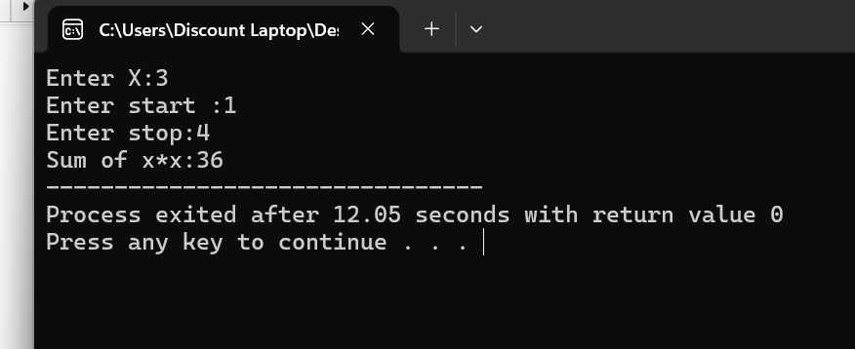

LAB TASK : 02

CODE:
#include <iostream>
using namespace std;

int main()
{
int a[50], n, x, value, i;

cout << "Enter size: ";
cin >> n;

cout << "Enter values: ";
for(i = 0; i < n; i++)
cin >> a[i];

// 1. Insert at end
cout << "Enter value to insert at end: ";
cin >> value;

a[n] = value;
n++;

// 2. Insert at start
cout << "Enter value to insert at start: ";
cin >> value;

for(i = n; i > 0; i--)
a[i] = a[i - 1];

a[0] = value;
n++;

// 3. Insert after specific value
cout << "Enter value after which to insert: ";
cin >> x;

cout << "Enter new value: ";
cin >> value;

for(i = 0; i < n; i++)
{
if(a[i] == x)
{
for(int j = n; j > i + 1; j--)
a[j] = a[j - 1];

a[i + 1] = value;
n++;
break;
}
}

// 4. Insert before specific value
cout << "Enter value before which to insert: ";
cin >> x;

cout << "Enter new value: ";
cin >> value;

for(i = 0; i < n; i++)
{
if(a[i] == x)
{
for(int j = n; j > i; j--)
a[j] = a[j - 1];

a[i] = value;
n++;
break;
}
}

// 5. Display
cout << "Array List: ";

for(i = 0; i < n; i++)
cout << a[i] << " ";

cout << endl;

// 6. Delete from end
n--;

// 7. Delete from start
for(i = 0; i < n - 1; i++)
a[i] = a[i + 1];

n--;

// 8. Delete specific value
cout << "Enter value to delete: ";
cin >> x;

for(i = 0; i < n; i++)
{
if(a[i] == x)
{
for(int j = i; j < n - 1; j++)
a[j] = a[j + 1];

n--;
break;
}
}

// Final List
cout << "Final List: ";

for(i = 0; i < n; i++)
cout << a[i] << " ";

return 0;
}

OUTPUT:

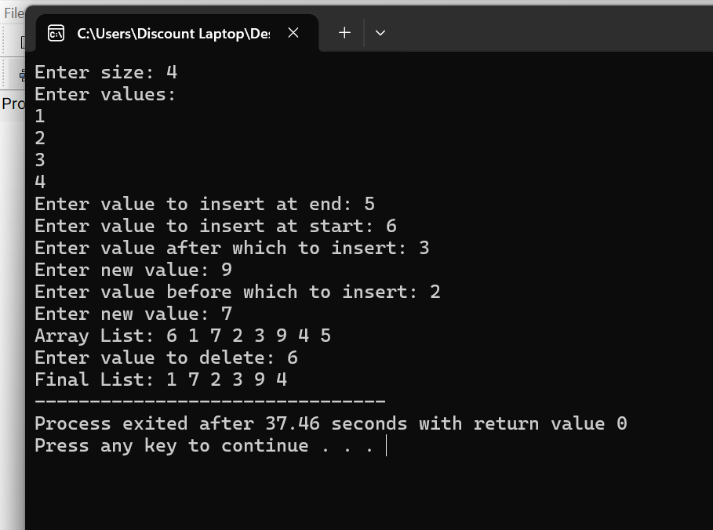

LAB TASK 03

CODE:
#include<iostream>
using namespace std;
int main(){
int data[10]={1,7,2,3,9,4};
int size =6;
int key;
cout<<"Enter value to search :";
cin>> key;
int i=0;
while(i<size && data[i]!= key){
i++;

}
if(i<size){
cout<<"Found at index "<<i<<endl;

}
else{
cout<<"Not found"<<endl;
}
return 0;
}
OUTPUT:
